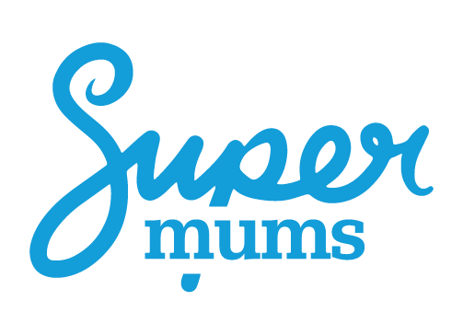

Updated November 2021
Course start and competition terms

ANZ Launch Terms

Course Start Terms
Supermums Training CIC is aiming to launch an ‘ANZ’ specific cohort in November 2021. This means, webinars, mentors and work experience all in an Australian time zone.
Supermums Training CIC is running a competition: if a minimum of 10 people apply and make payment for the course before 22nd October, we will give one place for free - i.e. one person will obtain a refund.
Please note the following terms:

Competition Terms
- This competition is open to applicants who apply for the Administrator Course starting in November 2021 in the ANZ region.
- An application and Training Agreement must be submitted and full or part payment made by Friday 22nd October
  - Full payment is $3770
  - Instalment option is 3 x $1330 due in consecutive months.
- All applicants who meet the above criteria will be automatically entered into the competition.
- The competition will only take place if at least 10 entries are made.
- One applicant ‘the winner’ will be selected at random to receive a full refund on their course fees.
- Providing criteria are met, the draw will take place the first week of November.
- The winner of the draw shall be refunded no later than 30th December. Refunds will ONLY be made to the original payee and account details and cannot be transferred to another party.
- All other Terms and Conditions as per the Training Agreement still stand.
- The Terms and Conditions outlined in the Training Agreement still apply - i.e. providing the course goes ahead, refunds shall NOT be made to those who do not win the draw.
- If for any reason the course does not commence in November, trainees will have the opportunity to transfer to an EMEA webinar time-zone, defer to February start or obtain a refund.

